Project Report

on

**VPocket**

Submitted as a part of course curriculum for

**Bachelor of Technology**

in

**Computer Science**



**Submitted by**

Ujjwal Kumar

1900290120124

**Under the Supervision of**

Name of the Guide

Designation

**KIET Group of Institutions, Ghaziabad**

**Department of Computer Science**

**Dr. A.P.J. Abdul Kalam Technical University**

**2021-2022**

**DECLARATION**

We hereby declare that this submission is our work and that, to the best of our knowledge and belief, it contains no material previously published or written by another person nor material which to a substantial extent has been accepted for the award of any other degree or diploma of the university or other institute of higher learning, except where due acknowledgement has been made in the text.

Signature of Student

Name: Ujjwal Kumar

Roll No.: 1900290120124

Date: 13-Dec-2021

**CERTIFICATE**

This is to certify that Project Report entitled “**VPocket**” which is submitted by **Ujjwal Kumar** in partial fulfilment of the requirement for the award of degree B. Tech. in Department of Computer Science of Dr A.P.J. Abdul Kalam Technical University, Lucknow is a record of the candidates own work carried out by them under my supervision. The matter embodied in this report is original and has not been submitted for the award of any other degree.

**Date:** 13-Dec-2021 **Supervisor Signature**

Supervisor Name

(Designation)

**ACKNOWLEDGEMENT**

It gives us a great sense of pleasure to present the synopsis of the B.Tech Mini Project undertaken during B.Tech. Third Year. We owe a special debt of gratitude to GUIDE NAME WITH DESIGNATION, Department of Computer Science, KIET Group of Institutions, Delhi- NCR, Ghaziabad, for his/her constant support and guidance throughout the course of our work. His sincerity, thoroughness and perseverance have been a constant source of inspiration for us. It is only his/her cognizant efforts that our endeavours have seen the light of the day.

We also take the opportunity to acknowledge the contribution of Dr. P. K Singh, Head of the Department of Computer Science, KIET Group of Institutions, Delhi- NCR, Ghaziabad, for his full support and assistance during the development of the project. We also do not like to miss the opportunity to acknowledge the contribution of all the faculty members of the department for their kind assistance and cooperation during the development of our project.

Last but not the least, we acknowledge our friends for their contribution to the completion of the project.

Signature:

Date: 13-Dec-2021

Name: Ujjwal Kumar

Roll No: 1900290120124

**ABSTRACT**

The internet era is growing faster than ever, and so is the demand for modern education. With this trend of technological advancement, people have tended to lose patience and become more restless, whether it be searching for the right article/blog or learning a new skill. Imagine reading an interesting article about 'Threats of Cryptojacking', but all you keep doing is going back and forth googling the meanings of words you don't get. We at VPocket caught such vulnerabilities and have come up with a reasonable solution to this issue.

VPOCKET - is a web application that allows the user to continue reading their engaging article/blog, double-click over the word you are unfamiliar with and let VPocket do the rest. Now that you have the complete description of this difficult word, you might still forget about it the next time you read it. We have something called 'pocket' where users can add words of their choice. Interactive and engaging games will be introduced to the users based on words from their pockets.

VPocket is just an initiative to make the learning experience more fun than monotonous. It is much more than a deep text corrector or dictionary app, rather a tool to improve users' learning experience and give them freedom.

**TABLE OF CONTENTS**

|  |  |
| --- | --- |
|  | Page No. |
| TITLE PAGE.................................................................................................................... | i |
| DECLARATION.............................................................................................................. | ii |
| CERTIFICATE …........................................................................................................... | iii |
| ACKNOWLEDGEMENT................................................................................................. | iv |
| ABSTRACT...................................................................................................................... | v |
|  |  |
| CHAPTER 1 INTRODUCTION | 1-2 |
| 1.1.          Introduction ……………………................................................... | 1 |
| 1.2 Problem Statement..……………………....................................... |  |
| 1.2.          Objective………………………………………………………… | 2 |
| 1.3.          Scope…………………………………………………………….. | 3 |
| CHAPTER 2 LITERATURE REVIEW…………………………………………….... | 7 |
| CHAPTER 3 PROPOSED METHODOLOGY …………………………………........ | 8 |
| CHAPTER 4 TECHNOLOGY USED ………..………………………..………………. | 12 |
| CHAPTER 5 DIAGRAMS …........................................................................................... |  |
| CHAPTER 6 CONCLUSION....................................................................................... |  |
| REFERENCES….............................................................................................................. |  |

1. **INTRODUCTION**

**1.1 Introduction**

VPocket is not just an extension; it is a web application and a tool that provides best learning experience and flexibility to its users. The demand of educational platforms like udemy, coursera and udacity is growing faster than ever. VPocket brings to you the most intelligent way to create  
your own stack of vocabulary. It provides a platform to learn, remember and frame a word by getting its meaning, which comes from collection of world largest and smartest dictionary  
with adaptive, engrossing, learning games that help you to master words out of your pocket.

**1.2 Problem Statement**

Learning something new and moreover remembering it seems to be a tricky job for few people and when we talk about vocabulary it seems like an ocean of words. Remembering the meaning of every word in the dictionary or googling the meaning of every word you don’t know is impossible and annoying too.

Even if googling sounds okay, building and improving vocabulary can be a huge and tedious process when referred over books or any other static method given that new words are kept on added to the English dictionary every year. A good vocabulary is always appreciated in every profession, in schools and in workplaces.

Things like vocabulary can never be taught in classrooms, more engaging and dynamic methods are expected to be much more productive instead. It is almost impossible to compare yourself with your fellow mates on the basis of your language and remembering skills. An online platform like VPocket has an objective to conquer issues like these for the enhancement of learning methods.

**1.3 Objective**

VPocket has the objective of providing quality education which is also entertaining and engaging for the learners. The learners can be of any age who wishes to learn English language vocabulary and build their grammar skills.

It would certainly include games, competitions, daily challenges and online competition with fellow users to get a world score and rank. Further, motivates you to accomplish your daily goal as set by the user itself. The user would immensely love the UI of the web application, moreover we would provide the user with best experience.

1. **LITERATURE REVIEW**

**Research Paper 1**

**Energy and Runtime Performance Optimization of Node.js Web Requests**

The Node.js framework uses an event-driven model with a single-threaded event loop and provides asynchronous and non-blocking I/O operations. As with other programs, Node.js web applications take advantage of underlying resources, including CPUs, which can incorporate the dynamic voltage and frequency scaling (DVFS) technique. Using CPU DVFS, the applications can increase their runtime performance, at the expense of the system’s energy consumption. Thus, software code that utilizes the CPU DVFS technique efficiently should lead to “green” and high-performing applications with respect to the business logic. To this end, we build a CPU frequency scaling/energy aware system to enable CPU frequency control within Node.js applications and measure the energy consumption of specific tasks. We also build a benchmark suite to analyze the energy consumption and runtime performance of different requests based on the CPU frequency impact and collect information and patterns, as we scale the CPU frequency. The analysis aims to provide data and knowledge on the CPU frequency “suitability” and impact in order to create a model for CPU frequency scaling on Node.js web applications and achieve an efficient and sustainable runtime performance.

**Research Paper 2**

**Research and Application of Node.js Core Technology**

Web development companies and developers can choose a variety of technology stacks to build Web applications. In the early days of network development, different technologies were used for front-end and back-end development. With the release of node.js, the construction of the website has undergone tremendous changes. Unlike single-threaded PHP and multi-threaded JAVA, a server programming platform based on the Chrome V8 engine JavaScript runtime environment-node.js came into being. Node.js uses its own built and defined attributes to make up for the shortcomings of the background development language in the traditional sense. It is a server-side JavaScript interpreter, which is used to conveniently build web applications with fast response speed and easy expansion. Node.js, with its event-driven, time loop mechanism, and non-blocking I/O model, can realize functions that Core JavaScript does not have or are not perfect, such as file systems, modules, packages, operating system APIs, and network communications. Historically, there has been more than one plan to port JavaScript outside the browser, but Node.js is the best one.

**Research Paper 3**

**A Review Paper on Cloud Computing**

Today is the era of Cloud Computing Technology in IT Industries. Cloud computing which is based on Internet has the most powerful architecture of computation. It reckons in of a compilation of integrated and networked hardware, software and internet infrastructure. It has various avails atop grid computing and other computing. In this paper, I have given a brief of evaluation of cloud computing by reviewing more than 30 articles on cloud computing. The outcome of this review signalizes the face of the IT industries before and after the cloud computing.

Like real clouds which are the collection of water molecules, the term ‘cloud’ in cloud computing is the collection of networks. The user can use the modalities of cloud computing boundlessly whenever demanded. Instead of setting up their own physical infrastructure, the users ordinarily prefer a mediator provider for the service of the internet in cloud computing. The users have to pay only for the services they had used.

**Research Paper 4**

**The Design and Implementation of a RESTful IoT**

**Service Using the MERN Stack**

With the increasing number of Internet of Things applications (IoT), an enormous number of IoT devices are connected to the Internet and require processing from the Cloud. Although the Cloud theoretically has unlimited resources, it is still a significant challenge for the Cloud to perform a real time response. This project is a designed and developed RESTful IoT service for a quick communication between IoT devices and the Cloud, using the MERN stack. As a gateway, the proposed system gathers data from IoT devices such as wireless sensors, for the Cloud to further process on it. The Representational State Transfer (REST) model is adopted in the proposed system. It has a good performance in terms of response time and scalability. Experiments further verified the performance of the proposed system.

IoT devices are characterized by small objects with limited storage and processing capacity. The integration of Cloud computing and IoT solves this issue in IoT and presents an architecture that is considered as a part of the Internet of the future.

**Research Paper 4**

**Autonomic Cloud Computing: Research Perspective**

Cloud computing is an evolving utility computing mechanism in which cloud consumer can detect, choose and utilize the resources (infrastructure, software and platform) and provide service to user based on pay per use model as computing utilities. Current computing mechanism is effective, particular for medium and small cloud based companies, in which it permits easy and reliable access to cloud services like infrastructure, software and platform. Present cloud computing is almost similar to the existing models: cluster computing and grid computing.

The important key technical features of cloud computing which includes autonomic service, rapid elasticity, end-to-end virtualization support, on-demand resource pooling and transparency in cloud billing. Further, non-technical features of cloud computing includes environment friendliness, little maintenance overhead, lower upfront costs, faster time to deployments, Service Level Agreement (SLA) and pay-as-you-go-model. In distributed computing environment, unpredictability of service is a fact, so same possible in cloud also. The success of next-generation Cloud Computing infrastructures will depend on how capably these infrastructures will discover and dynamically tolerate computing platforms, which meet randomly varying resource and service requirements of Cloud costumer applications.

**4. PROPOSED METHODOLOGY/DAIGRAMS**

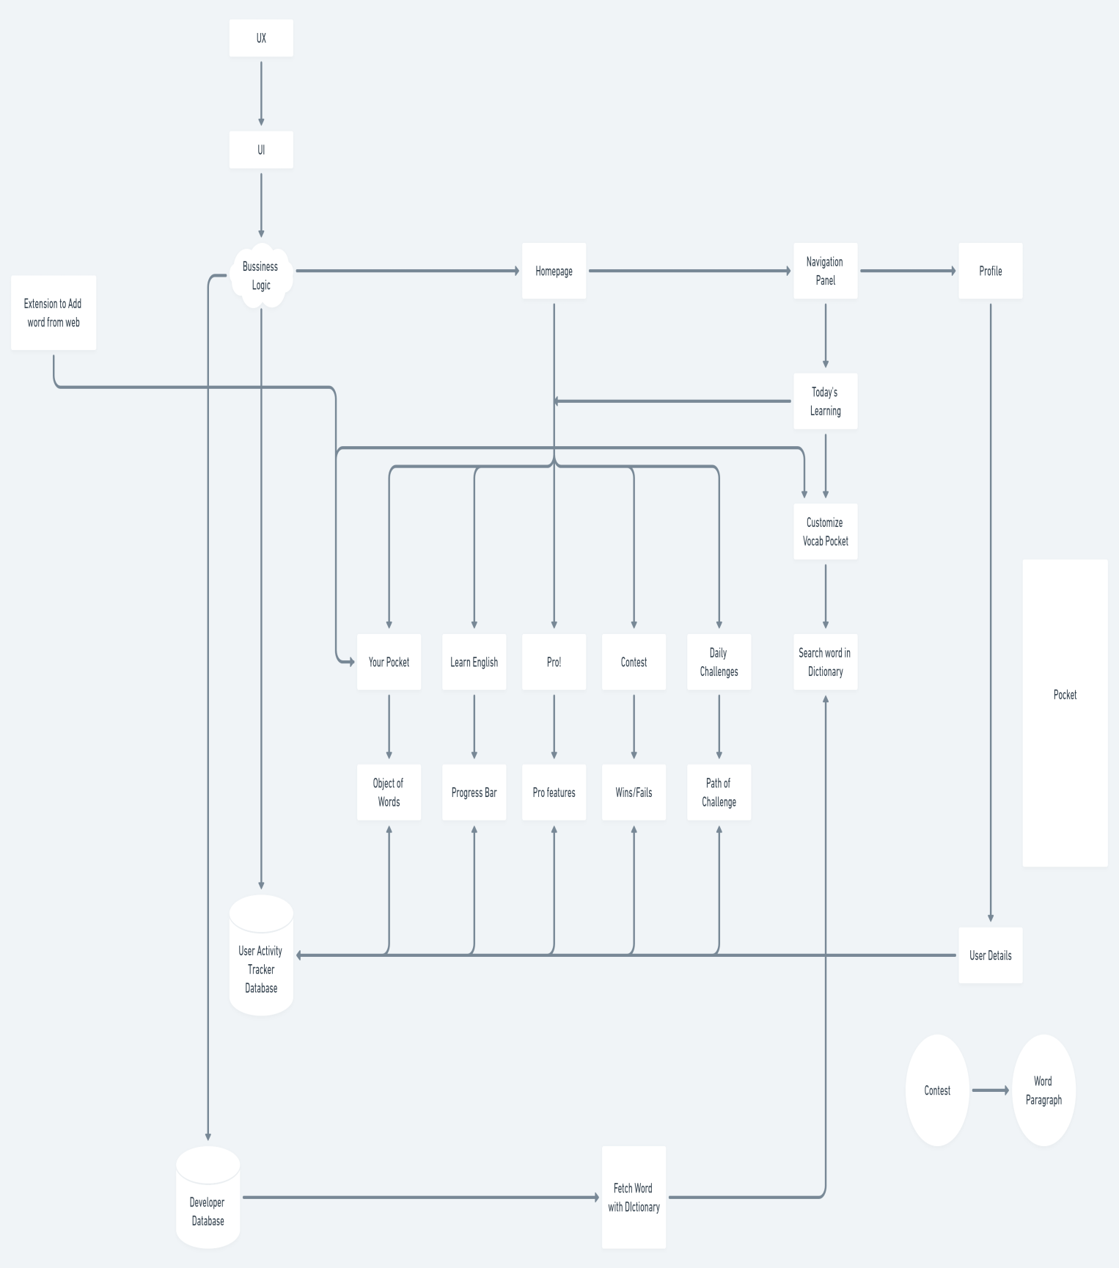

**Also a prototype of the homepage…**

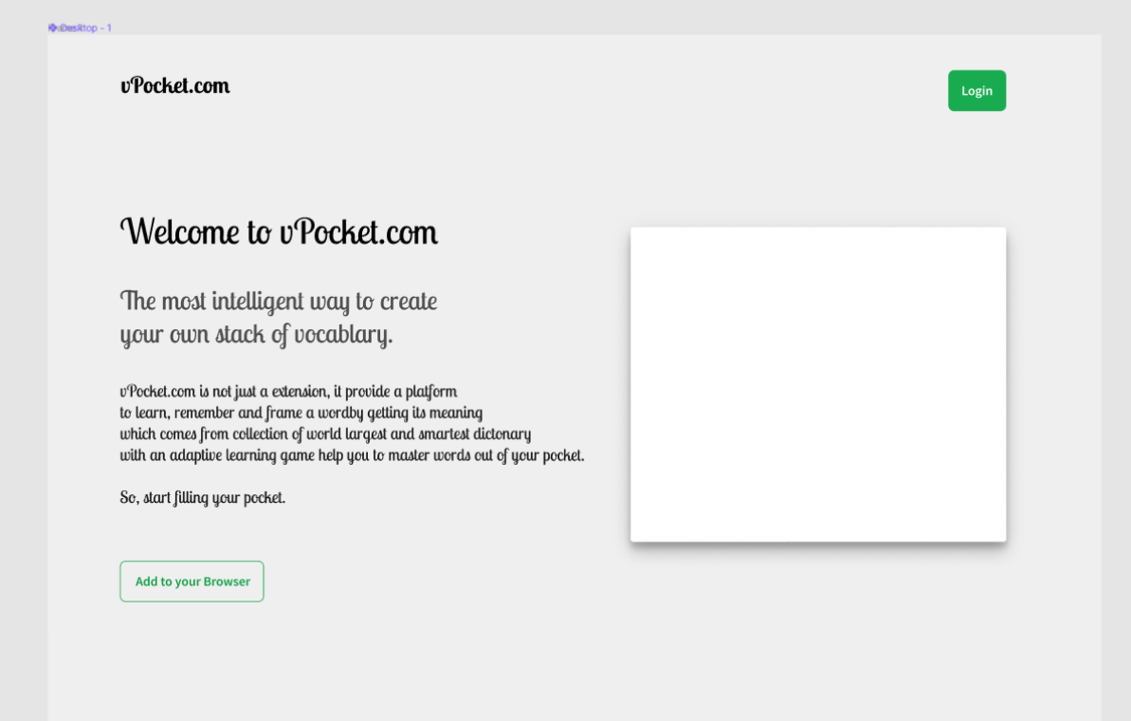

**5. TECHNOLOGY USED**

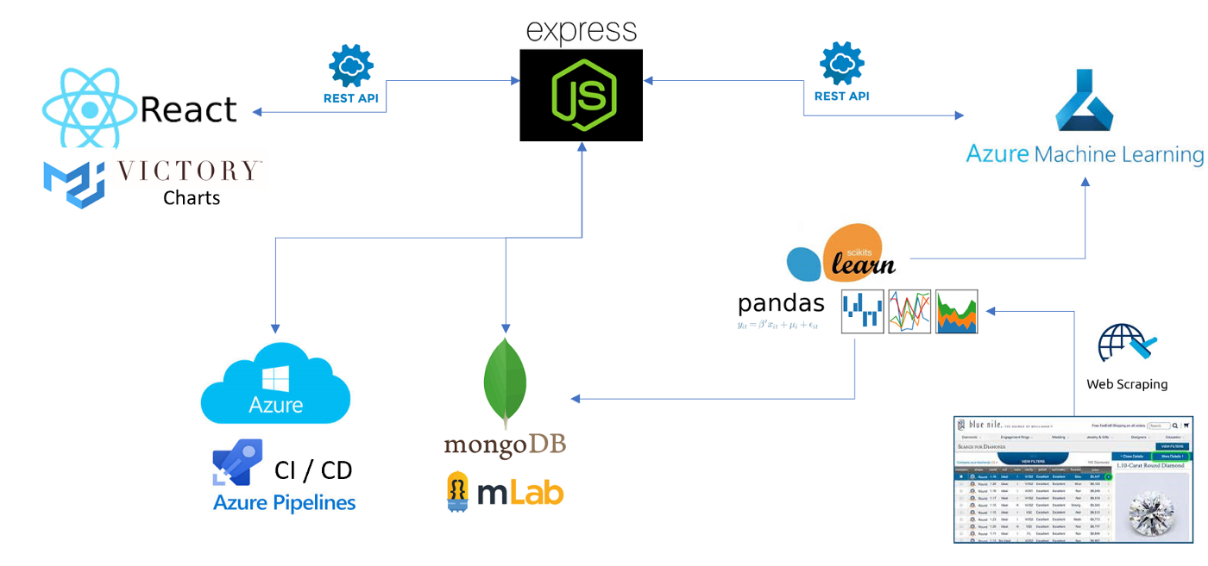

**TECH STACK USED:**

1. FRONT-END Development

Languages- HTML, CSS, TYPESCRIPT, ES6-JS

Framework- React.js/Next.js

2. BACK-END Development

Languages- TYPESCRIPT, ES6-JAVASCRIPT

Framework- Express.js

Based on- Node.js/Deno and NPM manager

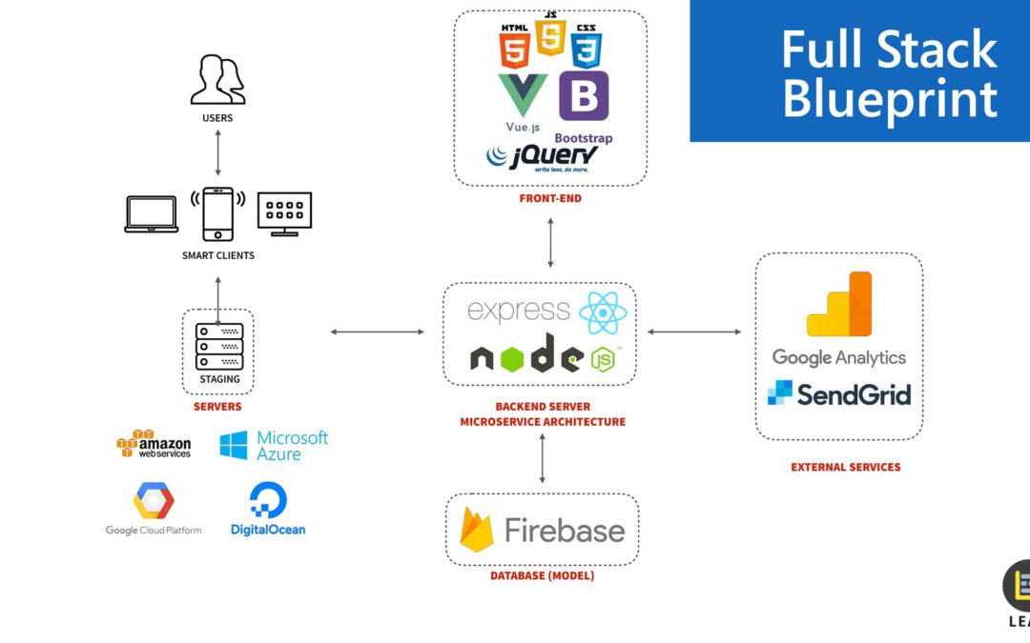

3. DevOps

Publish repos on Github

Maintain CI/CD pipelines through Azure/AWS cloud architecture

Deployment of application on DigitalOcean/Heroku/Netlify

Database integrated with application through Mongo DB atlas/Firebase

4. Authentication and Management

Basic authentication of application based on inside server algorithms like MD5/SHA256

User credentials stored using JSON-cookies parser, includes Firebase authentication/Passport.js

Application security management relays on Digital Ocean

5. Machine learning

Models training depend on user usability.

Integrate deep-text-correction modules.

Train application local host data.

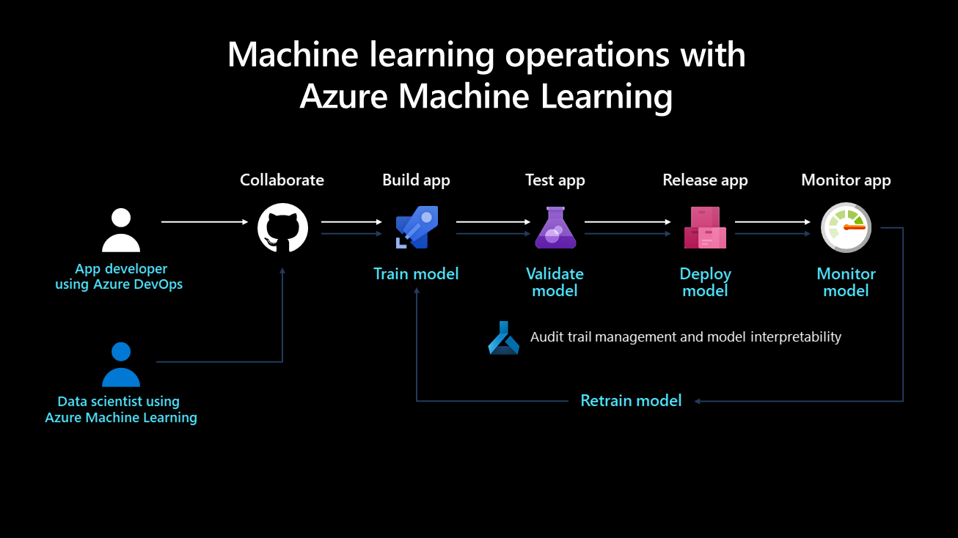

**6. CONCLUSION**

The internet era is growing faster than ever, and so is the demand for modern education. With this trend of technological advancement, people have tended to lose patience and become more restless, whether it be searching for the right article/blog or learning a new skill. Imagine reading an interesting article about 'Threats of Cryptojacking', but all you keep doing is going back and forth googling the meanings of words you don't get. We at VPocket caught such vulnerabilities and have come up with a reasonable solution to this issue.

VPocket is not just an extension; it is a web application and a tool that provides best learning experience and flexibility to its users. The demand of educational platforms like udemy, coursera and udacity is growing faster than ever. VPocket brings to you the most intelligent way to create  
your own stack of vocabulary. It provides a platform to learn, remember and frame a word by getting its meaning, which comes from collection of world largest and smartest dictionary  
with adaptive, engrossing, learning games that help you to master words out of your pocket.

Learning something new and moreover remembering it seems to be a tricky job for few people and when we talk about vocabulary it seems like an ocean of words. Remembering the meaning of every word in the dictionary or googling the meaning of every word you don’t know is impossible and annoying too.

Things like vocabulary can never be taught in classrooms, more engaging and dynamic methods are expected to be much more productive instead. It is almost impossible to compare yourself with your fellow mates on the basis of your language and remembering skills. An online platform like VPocket has an objective to conquer issues like these for the enhancement of learning methods.

VPocket has the objective of providing quality education which is also entertaining and engaging for the learners. The learners can be of any age who wishes to learn English language vocabulary and build their grammar skills.

It would certainly include games, competitions, daily challenges and online competition with fellow users to get a world score and rank. Further, motivates you to accomplish your daily goal as set by the user itself. The user would immensely love the UI of the web application, moreover we would provide the user with best experience.

**8. REFERENCES**

1. J. Rittinghouse and J. Ransome, “Cloud Computing: Implementaiton, Management, and Security”, CRC Press, Inc. 2009.

2. Garrison, G., Kim, S., Wakefield, R.L.: Success Factors for Deploying Cloud Computing. Commun. ACM. 55, 62–68 (2012).

3. Herhalt, J., Cochrane, K.: Exploring the Cloud: A Global Study of Governments‘ Adoption of Cloud (2012).

4. S. Sivakumar, V. Anuratha, and S. Gunasekaran, “Survey on Integration of Cloud Computing and Internet of Things Using Application Perspective”, International Journal of Emerging Research in Management and Technology. 6. 101-108. 10.23956/ijermt/SV6N4/101. 2. Barnard, R.W. and Kellogg, C. “Applications of Convolution Operators to Problems in Univalent Function Theory”,JSER., Vol.27, pp.81–94, 1987.

5. Sukhpal Singh, and Inderveer Chana. "Q-aware: Quality of Service based Cloud Resource Provisioning." Computers & Electrical Engineering - Journal - Elsevier. [http://dx.doi.org/10.1016/j.compeleceng.2015.02.003].

6. Sukhpal Singh, and Inderveer Chana. "QRSF: QoS-aware resource scheduling framework in cloud computing." The Journal of Supercomputing, Vol. 71, no. 1, pp: 241-292, 2015.

7. Zhang Zhaoyuan, a preliminary study on the back-end technology of web Node.js [J]. Small and Medium Enterprise Management and Technology 2020, Issue 22: 193-194.

8. Wang Jijie, design and implementation of a highly concurrent network application architecture based on Node.JS technology [J]. Journal of Tonghua Teachers College, 2020, Issue 7: 106-109.